**Problem Design Phase**

**Define the Problem Statements**

Date

25

June

202

5

Team ID

LTVIP2025TMID59666

Project Name

House

Hunt

App using MERN

Maximum Marks

3

Marks

**Customer Problem**

**Statement:**

**PS**

**-**

**1:**

**PS**

**-**

**2:**

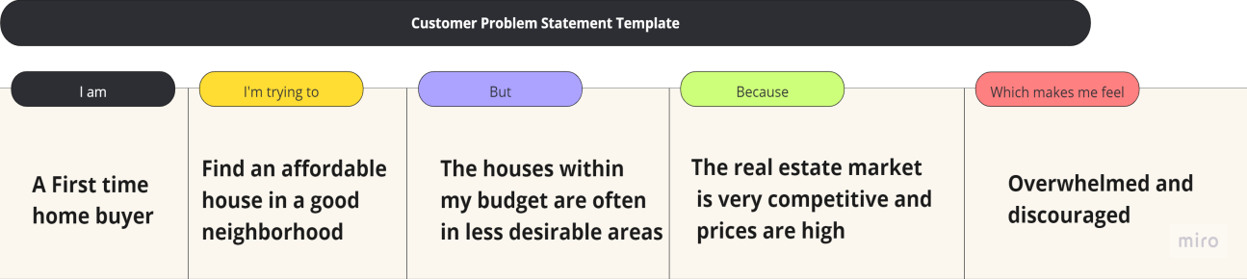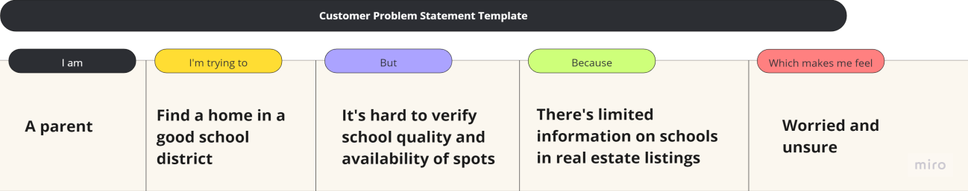

|  |  |  |  |  |  |  |  |  |  |  |  |  |  |  |  |  |  |  |
| --- | --- | --- | --- | --- | --- | --- | --- | --- | --- | --- | --- | --- | --- | --- | --- | --- | --- | --- |
| |  |  |  |  |  |  | | --- | --- | --- | --- | --- | --- | | **Problem**  **Statement (PS)** | **I am**  **(Customer)** | **I’m trying to** | **But** | **Because** | **Which makes me feel** | | PS-1 | A Firsttime home buyer | Find an affordable house in good neighbourhood | The houses within my budget are often in less desirable areas | The real estate market is very competitive and prices are high | Overwhelmed and discouraged | | PS-2 | A parent | Find a home in  a good school district | It's hard to verify school quality and availability of spots | There’s limited information on schools in real estate listings | Worried and unsure | |